Enrollment Table

|  |  |  |  |  |  |
| --- | --- | --- | --- | --- | --- |
| EVENTS | TRIGGER | SOURCE | USE CASE | RESPONSE | DESTINATION |
| Parent inquire registration and enrollment availability | Enrollment Day | Parent | Check for registration and enrollment availability | Registration and enrollment details | Parent/Admission |
| Parent pays corresponding tuition amount | Enrollment day | parent | Parent pays tuition | Cashier issues OR | Parent/Accounting |
| Parent checks Student validation | Enrollment day | parent | Registrar checks student assessment record | Issues new student assessment | Parent/student |

Student’s Event Table

|  |  |  |  |  |  |
| --- | --- | --- | --- | --- | --- |
| EVENTS | TRIGGER | SOURCE | USE CASE | RESPONSE | DESTINATION |
| Student wants to know the class standing | List of Honors | Student | View Class Standing | List of outstanding students Details | Student |
| Student wants to know his/her grade | Student’s Grade Inquiry | Student | View Student Grade | Student’s Grade Record | Student |
| Student wants to know her remaining tuition balance | Periodical exam permit | Student | Check Student balance and permit availability | Student’s Accounting record | Student |
| Student wants to consult a teacher | End of quarter consultation | student | Checks Subject teacher Availability | Teacher Consultation | Teacher |
| Student wants to know if they pass the periodical exam | Examination results | Student | Checks student exam results | Examination Results | Student |

Parent’s Event Table

|  |  |  |  |  |  |
| --- | --- | --- | --- | --- | --- |
| EVENTS | TRIGGER | SOURCE | USE CASE | RESPONSE | DESTINATION |
| Parents wants to see his/her child’s grade | Distribution of grades | Parent | Check student grade record | Student Report Card | Parent |
| Parent wants to pay his/her child’s tuition | Monthly tuition Payment | Parent | Accounting records and give out receipt to parents | Payment Validation | Cashier |
| Parent wants to inquire for the remaining balance of his/her child | Next Tuition Payment | Parent | Check student’s record in Accounting | Student Assessment | Cashier |
| Parent-teacher consultation | Parent Interview | Parent | Advisers talk/interview student’s with problem | Parent-teacher Consultation | Parent |
| Parents wants to see their child’s Class Standing or student status | End of quarter consultation | Parent | Adviser looks into Student record | Student Record Details | Parent |

Administrator’s Event Table

|  |  |  |  |  |  |
| --- | --- | --- | --- | --- | --- |
| EVENTS | TRIGGER | SOURCE | USE CASE | RESPONSE | DESTINATION |
| Advisers Submit grades of the student | Student Assessment | Admin | Record grades of students | Student grade average | Student/Adviser |
| Admin wants to encode students grade | Distribution of grades | Admin | Encode the grades of the student | Report cards | Student/parents |
| Admin monitors student grades | Student’s grade inquiry | Admin | Grade monitoring | Student’s grade | database |
| Admin validates the student grade | Student Assessment | Admin | Validate the student’s grade | Accurate and final grade | database |
| Admin wants to inform parents of his/her child’s outstanding balance | Informing Parents | Admin | Accounting gives parents the details of the outstanding balance | Tuition Fee Details | parents |
| Admin wants to inform Parent that his/her child is failing | Informing Parents | Admin | Adviser sends out a letter informing parents about students class standing | Class Standing Details | Parents |

Ghantt Chart

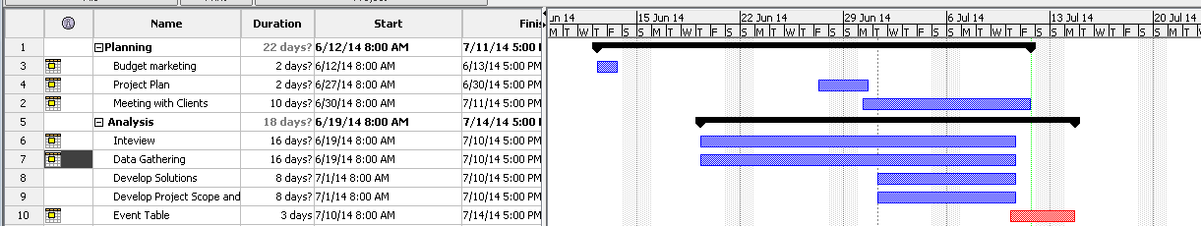

DFD

Students

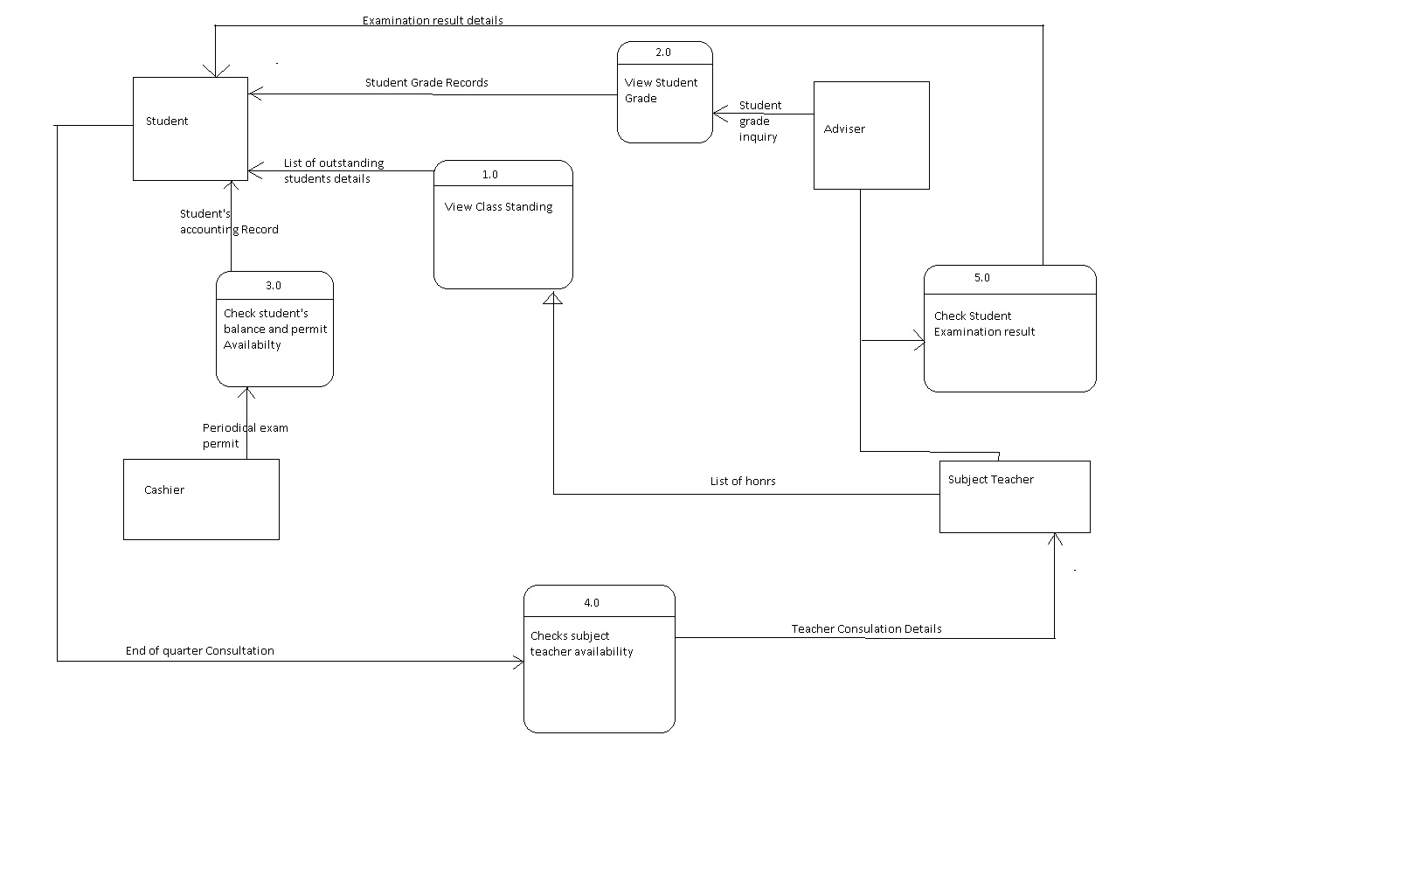

Parents

